Header Layout Variants
Our header offers multiple layout variations designed to deliver a premium and flexible user experience.
Initially, you can choose between two distinct header styles: Layout 1 and Layout 2.
Additionally, you have the option to position the logo either on the left or the right, allowing better alignment with your brand identity.

Layout 1
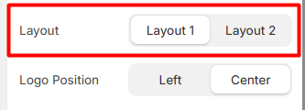
Layout 1 Preview
Layout 1 provides a clean and structured design with customizable navigation settings.

Navigation Options
Within this layout, you can select:
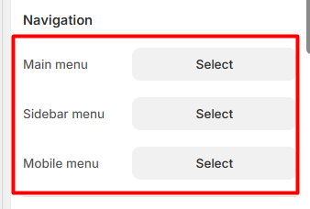
Each selected menu will be displayed accordingly within the header.
Main Menu Selection
Sidebar Menu Selection
Mobile Menu Selection
- The Mobile Menu is displayed only on mobile view for better responsiveness and user experience.
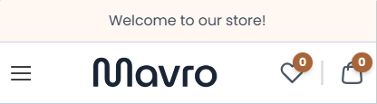
- Also you can choose the logo position for layout 1
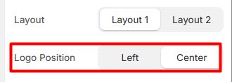

- Main Menu – Logo positioned in the center.
- Sidebar Menu – Logo positioned in the center.

Layout 2
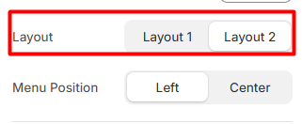

Layout 2 Preview
Layout 2 offers an alternative premium design with the same flexibility in navigation configuration.

Search Functionality
This layout includes a built-in search bar, allowing users to easily search for:
- Products
- Collections
This improves navigation efficiency and enhances the overall user experience.

Navigation Options
Similar to Layout 1, you can choose:
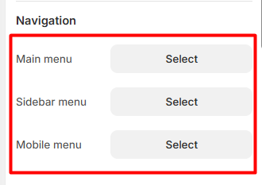
Each menu selection will dynamically adjust the header structure.

Main Menu Selection
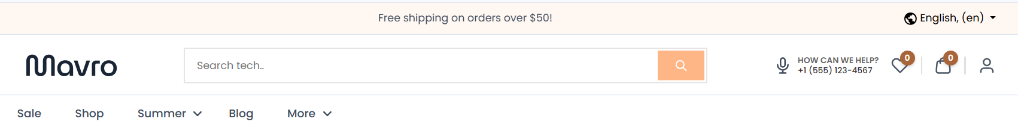
Sidebar Menu Selection
Mobile Menu Selection
- The Mobile Menu is displayed only on mobile view for better responsiveness and user experience.
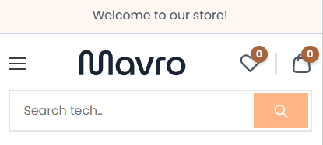
- Main Menu – positioned in the center.
